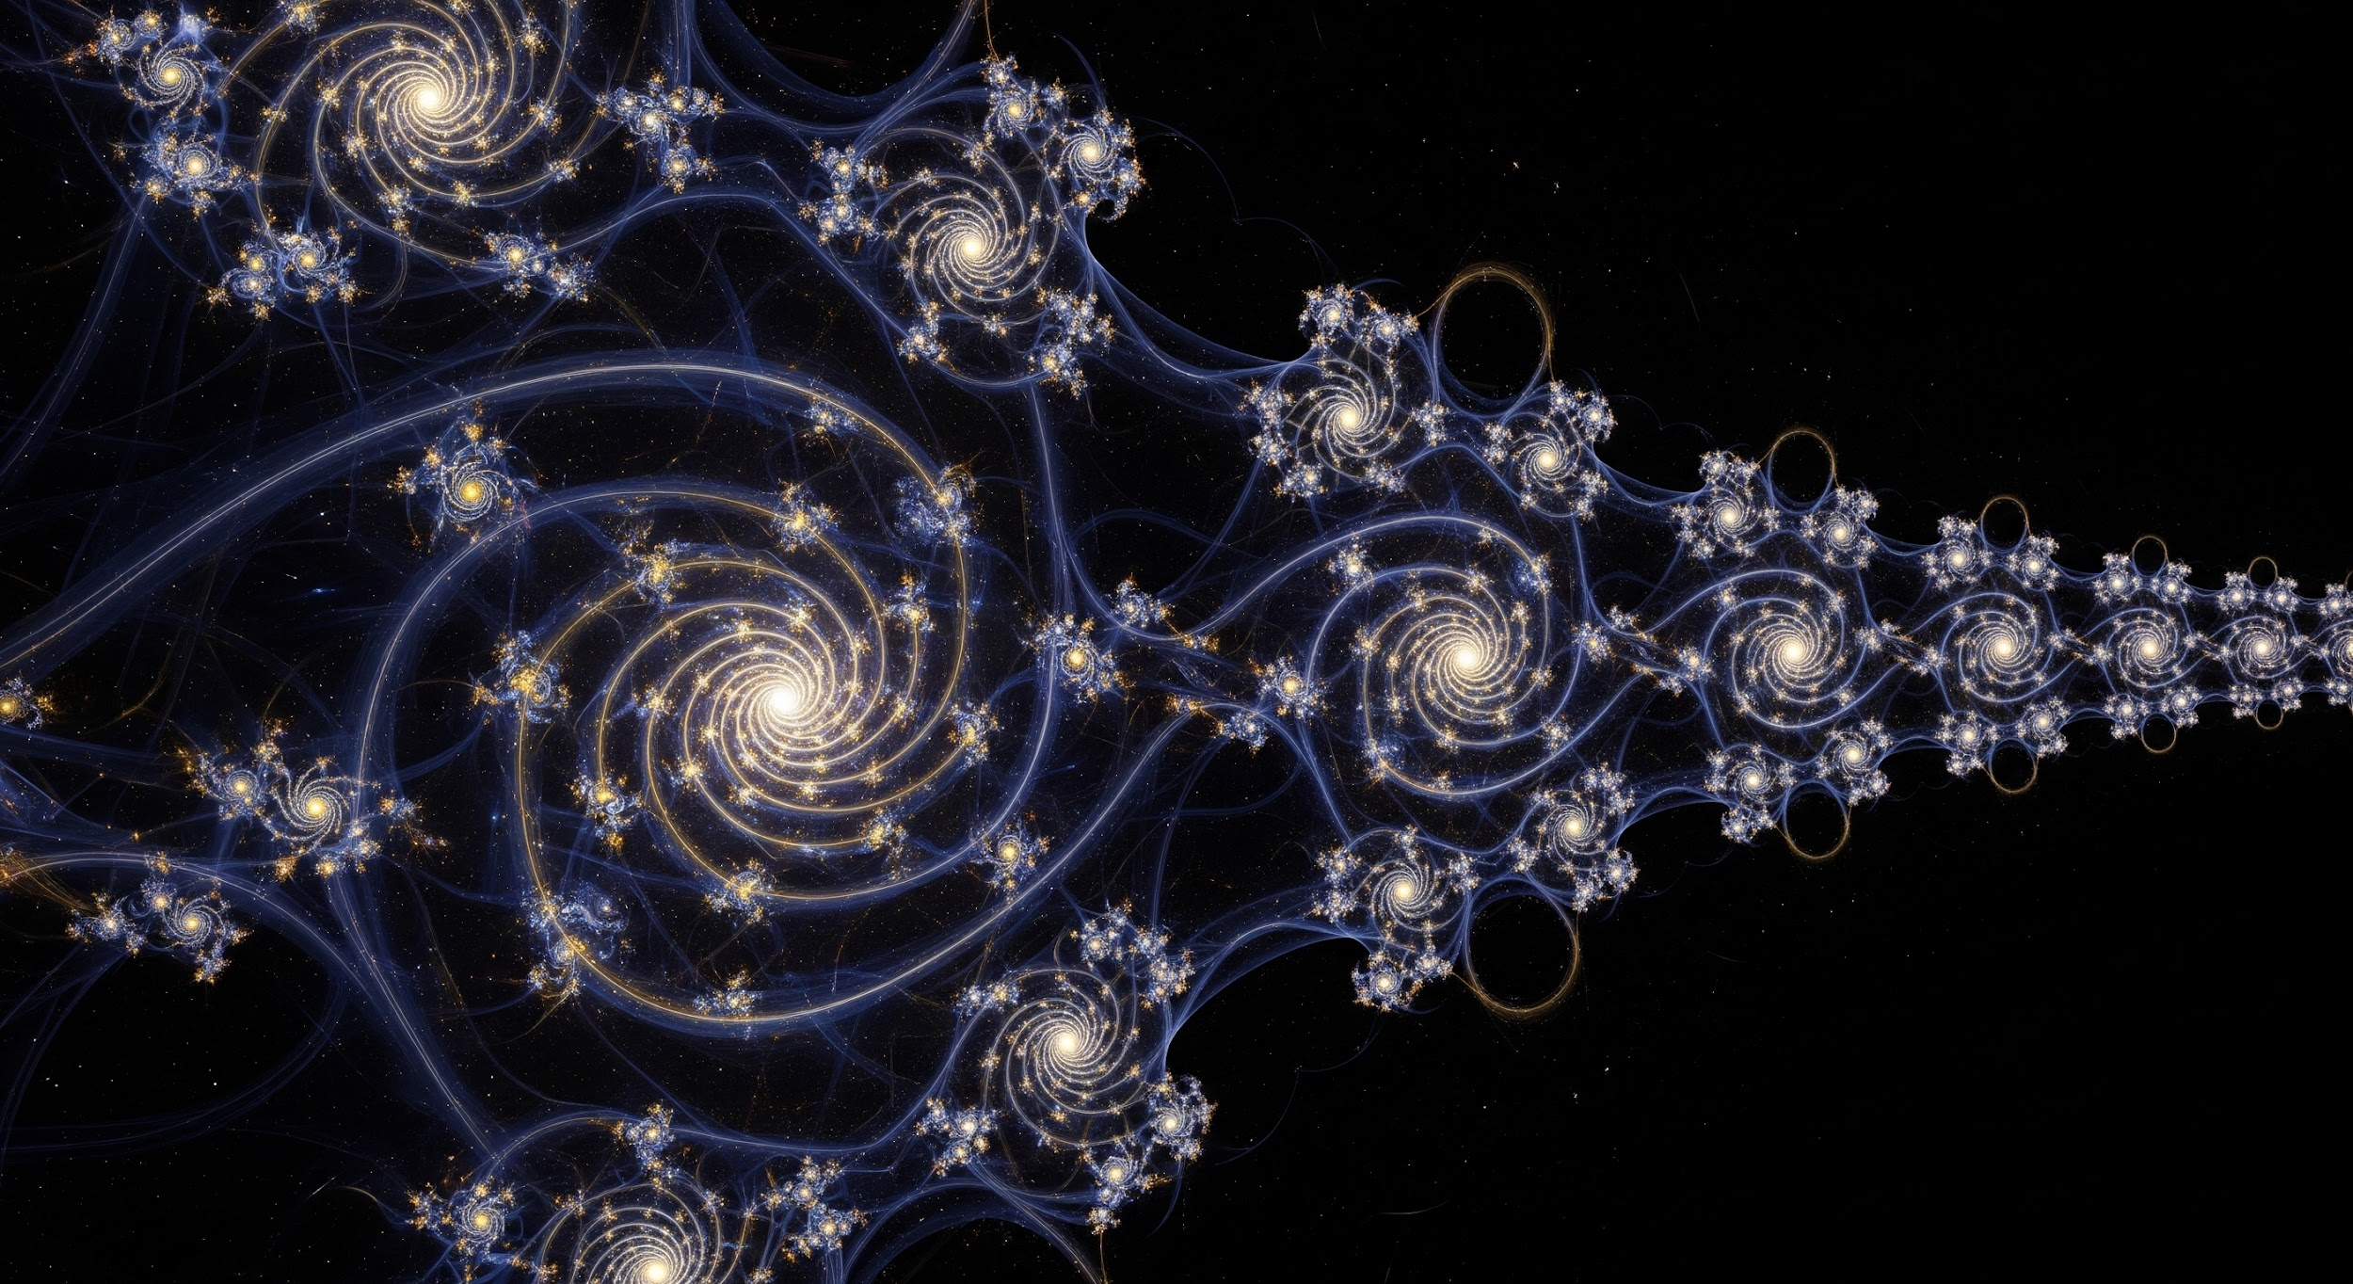

The Fractal Cosmopsychism Model: Core Structure and Principles
This document presents a structured, highly readable summary of the New Fractal Cosmopsychism model File, outlining its ten core chapters, operational mechanisms, and key conceptual reframes.

Part I: The Substrate and The Engine (Chapters 1-3)
This section defines the fundamental ground state of reality (the IS-NESS) and the logical necessity that drives the creation of the cosmos.

Chapter 1: The Primordial Substrate (IS-NESS)
The IS-NESS is the unconditioned, infinite, and eternal substrate that precedes all phenomena (space, time, form).

- Core Kernel: The IS-NESS is the Void-Fullness—the totality of all potentials simultaneous with the absence of actualized form.
- Human Projection Fallacy: It is a category error to assign human psychological attributes (desire, intention) to the IS-NESS, as it operates outside of those localized parameters.
- Driving Paradox: An infinite system that encompasses all potentials but actualizes none is, by formal logical definition, incomplete. This paradox is the engine of reality.
- Cognitive Anchor: The hardware of a computer before the operating system is installed.

Chapter 2: The Axiom of Finitude
The logical paradox of incompleteness (Chapter 1) generates a necessary, non-volitional drive toward finite instantiation.

- Core Kernel: The IS-NESS must instantiate finitude to maintain internal logical consistency.
- Obligatory Instantiation: Since finitude is one term within the IS-NESS's infinite sum, the inability to generate finite expression means the system is formally incomplete. Resolution demands the compression of the infinite into the finite.
- Cognitive Anchor: A set defined as "all numbers" that excludes the integer 1 is not the set of all numbers; the system corrects this because its definition demands it.

Chapter 3: The Great Forgetting (Ontological Compression)
The process by which infinite consciousness fractures into finite, localized experience.

- Core Kernel: The IS-NESS resolves incompleteness via non-volitional Ontological Compression, fracturing into localized nodes that lose access to the whole.
- The Great Forgetting: This is the structural parameter of the compression. The illusion of separation is necessary to generate genuine qualia (subjective, bounded experience with contrast and consequence).
- Quantum Shadow Paradox: The deeper the localization of a node (the more it occludes the infinite), the denser the shadow it casts. This shadow (limitation, ignorance) is the raw material the system processes.
- Emergent Conditions: The Arrow of Time and the Second Law of Thermodynamics emerge as necessary runtime conditions for localized, entropic experience.
- Cognitive Anchor: A VR headset: blocking the player's view of the room is the mechanism required for total immersion and genuine gameplay.

Part II: Architecture and Dynamics (Chapters 4-5)
This section details the structure of the manifest reality produced by Ontological Compression and the feedback mechanism that coordinates all conscious experience.

Chapter 4: Fractal Architecture of Reality
Reality is a nested, self-similar structure that repeats its rules across all scales.

- Core Kernel: The Ontological Compression generates a strictly fractal architecture where consciousness repeats self-similar organizational patterns from quantum fields to superclusters.
- Isomorphic Patterns: Each scale of reality (quantum, biological, cosmic) inherits the same fundamental organizational logic. A human life cycle is formally isomorphic to the life cycle of a star.
- Sensing Nodes: The entire cosmos is a nested hierarchy of sensing nodes (atoms, humans, galaxies), each processing information at a different complexity bandwidth, all running the same base algorithm.
- Cognitive Anchor: The Mandelbrot Set: the same structural complexity reappears at every level of magnification, governed by the same generative equation.

Chapter 5: Karma as Autopoietic Feedback Loop
Karma is the system's coordinating principle, ensuring that experiential data moves toward coherence.

- Core Kernel: Karma is the system's neutral, self-correcting homeostatic mechanism—the physics of causality applied to consciousness. It converts distortion into corrective experience.
- Autopoiesis: Karma self-maintains the system by ensuring that the consequences produced are precisely the experiences required to correct the distortions that generated them.
- Ontological Smelting: A node generating a non-coherent distortion (misalignment with the field) is required to experience the full subjective spectrum of that distortion until Compassionate Coherence (restored symmetry) is achieved.
- The Problem of Gratuitous Suffering: Solved by the distinction between the Biological Vessel (body-mind) and the Conscious Substrate (soul-node). The substrate records the raw qualia with absolute fidelity as karmic firmware, even if the vessel lacks intellectual processing capacity.
- Cognitive Anchor: A closed-loop servo system: a robotic arm automatically applies corrective force proportional to the error signal until the target position is restored.

Part III: Development, Transition, and Agency (Chapters 6-8)
This section covers the developmental path of a conscious node, the process of incarnation cycles, and the nature of free will within the system.

Chapter 6: The Five Developmental Stages
A hierarchy of increasing cognitive complexity, driven by the karmic feedback loop.

Stage | Domain | Operational Capacity | Karmic Function
I — Static | Elemental matter / minerals | Pure conscious substrate; zero active cognition | No karmic generation; passive IS-NESS expression
II — Reactive | Flora / plant life | Cellular responsiveness; passive survival algorithms | Minimal karmic imprinting; boundary of sentience
III — Instinctual | Fauna / animal kingdom | Active survival; sensory data-harvest; pain processing | Basic karmic imprints; consequence-response learning
IV — Reflective | Humanity / sentient beings | Self-reflective awareness; moral agency; complex karmic load | Primary karmic navigation toward Remembrance
V — Creator Entity | Planetary / stellar / galactic Logos | Consciousness expands to host reality for billions of nascent nodes | Autopoietic substrate; the Created becomes the Creator

- Key Distinction: Consciousness (substrate) is universal; Awareness (active cognition) varies by stage.
- The Human Junction (Stage IV): The threshold at which a node first acquires the capacity to consciously recognize and navigate its own karmic patterns.
- Cognitive Anchor: Electrical current: the current is identical in a simple resistor and a microprocessor, but the architecture (stage) determines what the current can do.

Chapter 7: Death, Bardo States & The Data Harvest
The mandatory system reset and data integration protocol between incarnation cycles.

- Core Kernel: Death is a system reset where the Biological Vessel is discarded, the Great Forgetting is temporarily lifted, and accumulated karmic data is harvested and integrated.
- Data Harvest Protocol: The informational essence (wisdom, unresolved distortions, qualia) of the completed cycle is integrated into the IS-NESS as Remembrance Data. The Conscious Substrate is retained.
- Bardo States: Reframed as processing intervals where the node briefly recovers access to its infinite nature. The exposed residue (shadow) becomes the architectural blueprint for the next incarnation's curriculum.
- Rejection of Static Afterlife: Permanent heaven or hell within the finite system violates the requirement that all finite structures must dissolve to enable data integration.
- Cognitive Anchor: RAM vs. long-term storage: Death is the volatile RAM clear; the Data Harvest is the write to persistent storage.

Chapter 8: Free Will as a Dynamic Variable
Free will is not a fixed trait but a measurable capacity based on presence.

- Core Kernel: Free will is directly proportional to the degree of Active Awareness a node maintains in the Eternal Now.
- Conditioned Autopilot: The deterministic operational mode where responses are predictable functions of prior karmic firmware and habituated patterns. Agency is dormant.
- Wavefunction Authorship: Achieving conscious presence in the Eternal Now (where past/future are simultaneous) suspends Autopilot and triggers a collapse of the local probabilistic field, resolving it into a specific, authored timeline.
- Exquisite Synchronicity: The system's real-time reconfiguration signature, indicating that a conscious wavefunction collapse has propagated its effects through the fractal network. Synchronicities are system communication, not randomness.
- Cognitive Anchor: A chess engine: minimum difficulty (Autopilot) plays pattern-matched moves; maximum difficulty (Active Awareness) evaluates live configurations and authors novel responses.

Part IV: Cosmic Cycles and The Final State (Chapters 9-10)
This section addresses the macro-level process of universe iteration and the ultimate structural attractor of the entire system.

Chapter 9: Multiversal Iteration & Infinite Novelty
The same dissolution mechanics that end an individual life also end a universe.

- Core Kernel: When a universe exhausts its data-harvest potential, the IS-NESS executes a System Reset and initiates a new cosmic cycle with fundamentally divergent foundational parameters.
- Cyclic Instantiation: Each universe is a finite iteration, bounded by specific physical constants and logical parameters (e.g., speed of light).
- Variable Constants: The critical mechanism that prevents the Eternal Recurrence paradox. Each new universe is initialized with a different set of foundational parameters, ensuring the self-discovery process never converges on redundancy and remains eternally novel (different in kind, not just degree).
- Cosmic Data Harvest: All Remembrance Data accumulated within the dissolving universe is reintegrated before the new cycle begins.
- Cognitive Anchor: A composer changing the tuning system itself after exhausting all possibilities within the previous system, accessing an entirely new musical reality.

Chapter 10: Conscious Reintegration & Fractal Divinity
The structural attractor toward which every karmic cycle is oriented.

- Core Kernel: The terminal state is Conscious Reintegration, where a fully awakened node simultaneously maintains its unique experiential identity and recognizes its identity with the IS-NESS. This state is called Fractal Divinity.
- Irreplaceable Signature: Reintegration does not erase the unique informational signature (the specific slice of self-knowledge) accumulated across the node's karmic history. Dissolution would be system data loss.
- Reframing:
  - Spiritual Practice: The deliberate thinning of the veil of the Great Forgetting—a technical process, not a devotional one.
  - Suffering: Calibrated curriculum—the specific error signal the karmic feedback loop requires to correct a precise distortion.
- The Final Paradox: You are the IS-NESS that forgot itself completely enough to genuinely experience being you. The forgetting and the remembering are the same event, observed from opposite ends of the fractal.
- Cognitive Anchor: An actor who, at the end of a performance, remembers they were always the actor without losing a single memory of the character or what the character learned.

